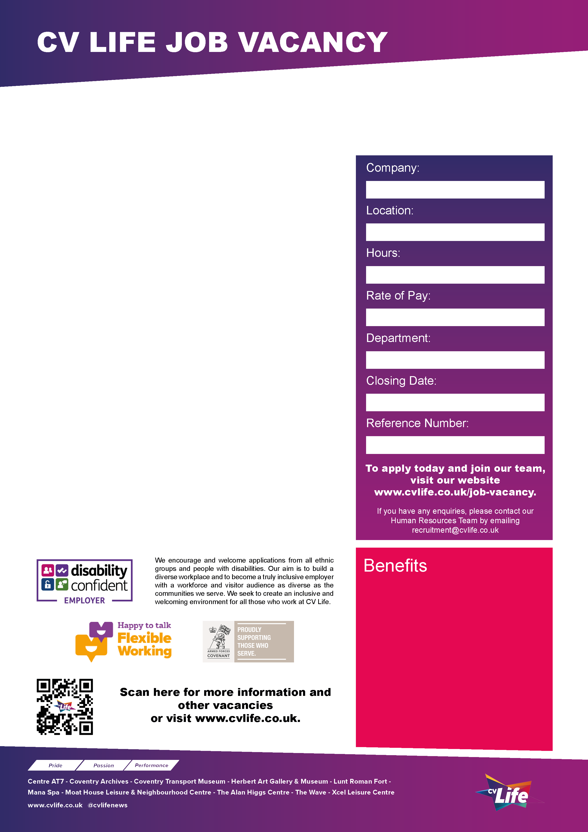
CVLife are looking for a Visitor Services Assistant to join the Visitor Services team at Coventry Transport Museum, to engage with visitors and help them gain a full appreciation and enjoyment of our collections, exhibitions events and activities.

As a Visitor Services Assistant your role will be to help maintain a presence in the galleries and various exhibitions, ensuring that they are a clean and safe environment for our visitors, as well as maintaining the safety and security of the collections.

We are looking for a candidate who:
- Has a good understanding of the importance of customer service including experience within a customer service setting.
- Can interact with visitors, providing a visible and welcoming point of contact and providing information to enhance visitor experience.
- Has strong communication skills – with a confident and friendly manner and able to adapt the communication style when needed.
- Is comfortable promoting retail promotions and maximising opportunities for donations to the museum.
- Is happy to provide information on exhibits.
- Can develop and maintain good product knowledge of the museum’s collections and exhibitions enabling you to interact with and support visitors to make the most of their visit.
- Has a positive and flexible ‘can do’ attitude.

Working days:
Friday and Sunday 9.15am-17.15pm
Interviews to take place week commencing 9th March 2026.

Apply today and Join Our Team!

CV Life is committed to safeguarding and promoting the welfare of children and vulnerable adults and expects all staff and volunteers to share this commitment.
Visitor Services Assistant
- Great development opportunities
- FREE health and fitness membership* **
- FREE health and fitness membership for a family member or friend* **
- FREE onsite parking at most sites
- FREE training for applicable roles
- DISCOUNTS on various Centre activities*
- FREE entry to venues*
- Access to our Employee Benefits platform

( **The two benefits combined can be worth £1000!)
(*not applicable to casual workers)

CCT083
25th February 2026
Operations
NLW/NMW
15 Hours
Coventry Transport Museum
Culture Coventry

