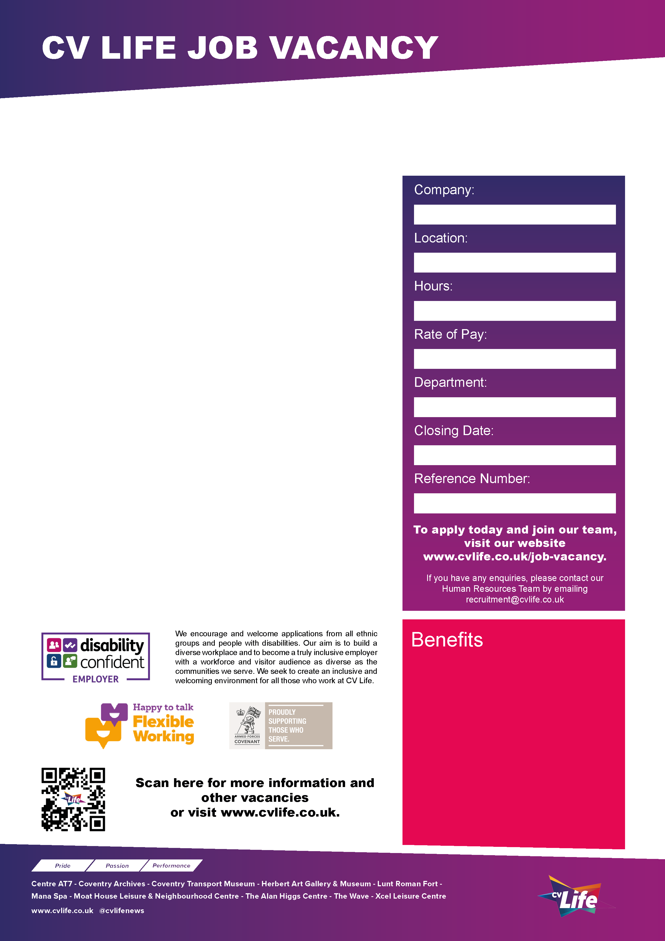
CCT079
14th November 2025
Human Resources
£25,833 per annum (pro-rata)
CV Life is committed to safeguarding and promoting the welfare of children and vulnerable adults and expects all staff and volunteers to share this commitment.
This role provides a fantastic opportunity for an experienced administrator who is interested in developing experience in a HR environment. It is a varied, fast paced, and busy role which will build on or broaden your current administrative experience.

You will provide administrative support within our small but very busy HR Team and will be the first point of contact for all internal and external HR enquiries. The role provides support to both Culture Coventry Trust and Coventry Sports Foundation on a shared services basis for CV Life, providing support to over 600 employees.

The successful candidate will have excellent interpersonal skills and must be able to demonstrate professional integrity along with strong administrative and IT skills and keen attention to detail. The role will also require someone who is well organised, able to work accurately at pace and able to work flexibly with changing priorities to support a very busy environment.

Role and Responsibilities:
- Provide administrative support for recruitment processes, placing adverts and processing applications etc.
- Manage the onboarding process of new employees, including right to work checks, obtaining references, and issuing employment documentation.
- To provide administrative support throughout the lifecycle of the employee, processing contract changes, and minuting meetings for formal procedures etc.
- Maintain and update electronic personnel record systems and support the development and implementation of a new digital platform and staff app.
- Prepare monthly payroll adjustments, including sickness absence reporting.
- Deal with confidential and sensitive information appropriately and in accordance with GDPR.
- Demonstrate a strong understanding and ability to use Outlook, Word, Excel, and MS Teams.
- Demonstrate excellent communication skills (both written and verbal)

Working hours are 37 per week, however there may be some flexibility to consider part-time working. The role is based primarily at The Coventry Transport Museum with free onsite parking, however you will be required to attend meetings and work across all CV Life sites within Coventry.

If you are looking for an opportunity to expand your experience, apply today and Join Our Team!

Human Resources Administrator
- Great development opportunities
- FREE health and fitness membership* **
- FREE health and fitness membership for a family member or friend* **
- FREE onsite parking at most sites
- FREE training for applicable roles
- DISCOUNTS on various Centre activities*
- FREE entry to venues*
- Access to our Employee Benefits platform

( **The two benefits combined can be worth £1000!)
(*not applicable to casual workers)

37 Hours
Coventry Transport Museum
Culture Coventry Trust

