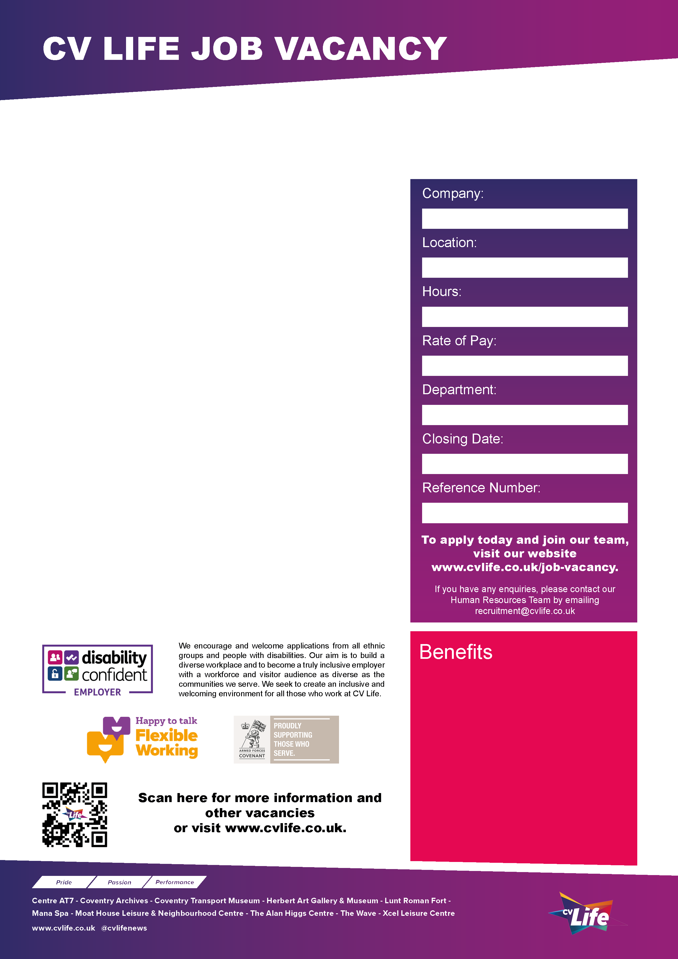
About the role:
We are looking for an individual to play the role of Santa for our vintage Sleigh Ride Experience at Coventry Transport Museum. Assisted by a team of Elves you will be responsible for creating memorable visits.
Main duties include:
- Greet Visitors on arrival into the Grotto while promoting the excitement of meeting Santa.
- Communicate with children and their families throughout the experience.
- Maintain the persona of Santa throughout the visitor’s experience, wearing the costume provided.
- Have your photo taken with visitors when requested.
- Ensure compliance with and understanding of all Health & Safety policies and requirements relevant to the position.
- Have a passion for Christmas and understand the importance of the role of Santa to children, demonstrating the required behaviours with confidence & enthusiasm.
- To be positive and flexible with a ‘can do’ attitude, to ensure a memorable experience for visitors
We are looking for candidates who:
Ideally have previous experience of playing the role of Santa in a grotto setting or working with children. You must have a passion for working with children and families, have a passion for Christmas and understand the importance of the role to children, and demonstrate the required behaviours with confidence and enthusiasm. You must have good communication skills, are positive and flexible with a ‘can do’ attitude to ensure a memorable experience for visitors.

Full training and Santa Costumes are provided, so if you can add the right ‘ho ho ho’ to our Christmas cheer, apply today and join in this year’s magical experience. There are various hours available for both morning and afternoon shifts, predominantly Saturday and Sunday from mid-November to 23rd December 2025.

Apply Today and Join Our Team!

CV Life is committed to safeguarding and promoting the welfare of children and vulnerable adults and expects all staff and volunteers to share this commitment.
Santa (Casual)
- Great development opportunities
- FREE health and fitness membership* **
- FREE health and fitness membership for a family member or friend* **
- FREE onsite parking at most sites
- FREE training for applicable roles
- DISCOUNTS on various Centre activities*
- FREE entry to venues*
- Access to our Employee Benefits platform

( **The two benefits combined can be worth £1000!)
(*not applicable to casual workers)

CCT078
5th November 2025
Operations
£20 per hour
Casual (Temporary Contract)
Coventry Transport Museum
Culture Coventry

