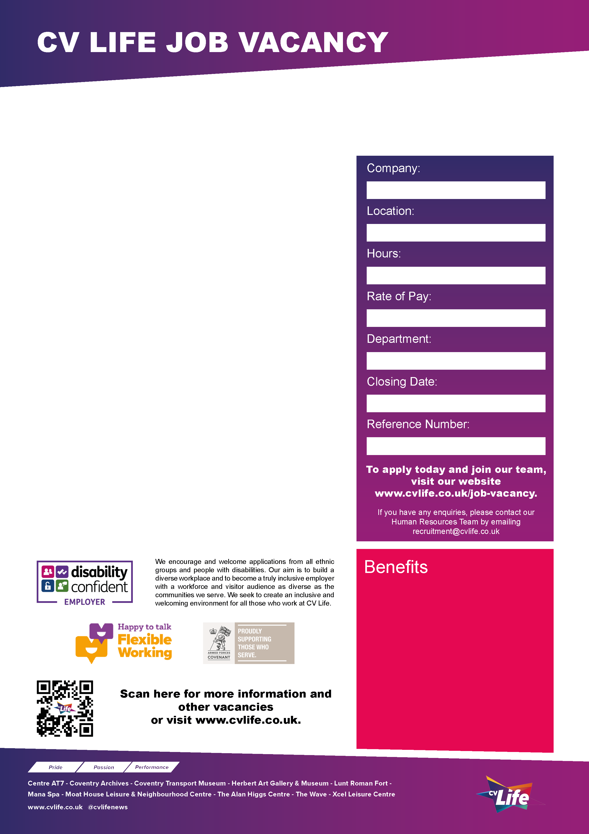
CVLife prides itself on delivering the highest standard of cleanliness throughout our centres and venues. At The Coventry Transport Museum your job would be to ensure visitors receive a good impression of the museum and galleries. You would contribute at all times to the general upkeep of the building by reporting significant items of concern to the Venue Manager.

We are currently looking to recruit two enthusiastic and reliable Cleaning Assistants to join our growing team Coventry Transport Museum in Coventry City Centre.

The successful applicants will be responsible for providing a professional cleaning service with an ability to undertake manual tasks to ensure a hygienic clean to all public areas. As a CVLife cleaner you will be dependable and take pride in your work and deliver a consistent service.

Duties will include:
- Sweeping, mopping, and vacuuming floor spaces.
- Sanitising and polishing surfaces.
- Cleaning facilities as required.

Previous experience in a similar role is preferred.
We are looking for someone with a can-do attitude, a team player spirit and who can also use their own initiative and is willing to help in all areas when needed.

The hours available are:
Monday, Wednesday, Thursday, Friday and Sunday 8.00am-10.00am.

Apply today and join our team!

Come Join Our Team and apply today!

CV Life is committed to safeguarding and promoting the welfare of children and vulnerable adults and expects all staff and volunteers to share this commitment.
Coventry Transport Museum
Cleaner
- Great development opportunities
- FREE health and fitness membership* **
- FREE health and fitness membership for a family member or friend* **
- FREE onsite parking at most sites
- FREE training for applicable roles
- DISCOUNTS on various Centre activities*
- FREE entry to venues*
- Access to our Employee Benefits platform

( **The two benefits combined can be worth £1000!)
(*not applicable to casual workers)

CCT082
30th January 2026
Operations
NLW/NWM
10 Hours
Culture Coventry

